HARPUR TRUST ART COMPETITION 2019/20
‘THE FABRIC OF BEDFORD’
Schools Pack
We would like to invite your school to take part in our third Harpur Trust Art Competition, open to all schools across Bedford Borough.
The competition will run from September 2019 over the autumn and spring terms during which time we will be offering free workshops for up to 35 state schools (on a first come first served basis). The competition will culminate in the summer of 2020 with a professional exhibition, of selected children’s work at The Higgins Bedford and there will be a special preview evening during which we will present the prizes.
 | 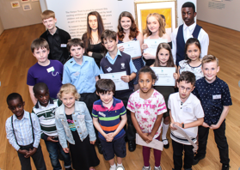 | 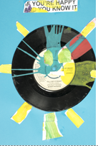
COMPETITION THEME
This year, the theme of our competition is ‘The Fabric of Bedford’. The Harpur Trust is part of the fabric of Bedford. We’ve been here in the town for over 450 years and as well as running our schools, we make grants to local charitable organisations and voluntary groups to the tune of £1 million each year. We also look after older people in the town through our almshouses and other accommodation. We would like to know what you think captures the heart of Bedford and makes our town unique? You might choose a particular organisation or an industry. You could portray a person or people you feel best represent our town. You might select a shop, café, library or sports club or charitable organisation that is special to you, or you may focus on the town’s buildings or bridges. You could explore community and diversity, or consider the history of the town and how it has evolved. Feel free to focus on one aspect of Bedford life, or if you prefer, produce a montage of all the things that you feel make Bedford the town that it is.
All we ask is that you add some text on the back of your piece of art to explain what you have produced and how you feel it fits with the theme.
AGE CATEGORIES
The competition is open to all 4-18 year olds at school within Bedford Borough, who can enter individually or through their school. Schools can enter in one or more of the following categories, but no more than 8 entries per age category should be submitted:
Category 1 | Ages 4-7 | Reception, Years 1 and 2
Category 2 | Ages 7-11 | Years 3, 4, 5 and 6
Category 3 | Ages 11-14 | Years 7, 8 and 9
Category 4 | Ages 14-16 | Years 10 and 11
Category 5 | Age 16-18 | Years 12 and 13
CRITERIA FOR ARTWORK
It is important that you read this section carefully and that you ensure all work adheres to the requirements. If artwork does not comply we regret that we may not be able to accept it.
- Artwork submitted must be 2D (by this we mean it should be relatively flat and suitable for framing with glass). If it can’t be framed we can’t use it.
- Size should be either A4, A3 or A2 (this is to enable us to frame selected entries in a cost effective way).
- Entries can be produced on paper, fabric or even on a ceramic tile but they must adhere to the size guidelines above.
- Work should arrive unmounted and unframed.
- Entrants can use a range of materials and techniques from the following list: drawing (e.g. pencil, pen, crayon, pastel, etc.), painting, printmaking, collage and montage (photography can be integrated into the piece but we will not accept a standalone photographic entry).
- Each school can submit a maximum of 8 entries per age category.

FREE SCHOOL BASED ARTIST WORKSHOP GIVEAWAY & STAFF INSET SESSIONS
To help you prepare your pupils for the competition, we are also offering all state schools the opportunity to apply for one of 35 free workshops focussed around the theme of the competition, exploring a variety of art mediums and techniques.
Workshops will be allocated on a first come first served basis (a maximum of one workshop per school).
In addition, The Harpur Trust and The Higgins Bedford are offering 2 further workshops specifically for staff which will be hosted at The Higgins Bedford. One workshop is aimed at non-specialist art teachers, and the other is for specialist art teachers who might wish to explore a new medium. This workshop will involve a carousel of artists providing a range of ideas and techniques.
Inset for non-specialist Art Teachers: 2nd October 2019 4-6pm
Inset for specialist Art Teachers: 9th October 2019 4-6pm
To apply for a Visiting Artist Workshop and/or a staff inset workshop, please complete and return Form 1.
JUDGING
Judging will take place in April 2020 and winning schools will be notified on 15th May 2020. Around 120 - 140 entries will be selected for display at a public exhibition at The Higgins Bedford from Saturday 11th July 2020 to Sunday 13th September 2020. Entries will be judged on both originality and creativity and judges will be looking for an imaginative response to the themes. Judges will also look at:
- Content – what story does the picture tell or what message does it give?
- Composition – where and how is everything placed?
- The atmosphere and mood created by the piece.
- Whether the entrant has fulfilled the requirements set out in the criteria section.
PRIZES
3 Prizes will be awarded in each of the following age-groups: 4-7, 7-11, 11-14, 14-16 and 16-18 years.
1st Prize: | £300 of arts materials for the school. | £60 of vouchers for the child.
2nd Prize: | £200 of arts materials for the school. | £30 of vouchers for the child.
3rd Prize: | £100 of arts materials for the school. | £15 of vouchers for the child.
Entrants whose work is selected for the exhibition will have their work professionally framed (pupils can keep the framed work at the end of the exhibition). We will also provide them with a certificate.
ABOUT THE HARPUR TRUST
Throughout our history, we have been inspiring and supporting people within the Borough of Bedford, using the legacy of our founder Sir William Harpur to provide and promote education, to provide relief and help to those who are sick, in hardship or distress, and to provide recreational facilities with a social welfare purpose. Above all, we want everyone to have pride in their community and to be given opportunities to realise their own potential. As such, we are delighted to offer this competition which we hope will inspire local children to explore their artistic talent, and to encourage them to engage in a project which could result in their work being displayed to the general public in an exhibition at The Higgins Bedford in the summer of 2020.
FURTHER INFORMATION
Please contact: Sarah Elam at The Harpur Trust:
Princeton Court, Pilgrim Centre, Brickhill Drive, Bedford, MK41 7PZ
Tel 01234 369519 selam@harpurtrust.org.uk Sarah Elam

www.harpurtrust.org.uk/art-competition-2020
TERMS AND CONDITIONS

By entering the competition, schools and entrants confirm that they have read and understood, and agree to be bound by, the following competition rules:
1. The competition is open to all pupils and schools in Bedford Borough.
2. Entries must be delivered via post or by hand to The Harpur Trust, Princeton Court, Pilgrim Centre, Brickhill Drive, Bedford MK41 7PZ. Entries cannot be delivered electronically and they must be the original artwork.
3. Only one entry to the competition per pupil shall be accepted. A pupil can enter as an individual or through their school.
4. All schools who receive a free workshop are required to submit artwork to the competition. Failure to do so will result in a charge being made for the workshop.
5. Entry to the competition is free, however, all materials for the creation and submission of artwork must be provided by the school.
6. All artwork must be the original idea of the entrant and not infringe on anyone else’s copyright.
7. Entries must be received no later than 4.00pm on Friday 27th March 2020.
8.a School entries - Each individual artwork must have the pupil’s name and school marked clearly on the back and Forms 2 and 3 must be submitted with the artwork.
8.b Individual entries – please ensure your name, age, address and contact telephone number are marked clearly and legibly on the back of your artwork.
8.c The information provided on entrants will only be used by The Harpur Trust and The Higgins Bedford for the purposes of the competition.
9. Artwork cannot be returned by post and schools and individual entrants are required to collect artwork between Monday 28th September 2020 and Friday 23rd October 2020 from The Harpur Trust office. After this date, we regret that uncollected artwork may be disposed of.
10.a Winning schools will be informed of the results by 4.00pm on Friday 15th May 2020 and results will be posted on The Harpur Trust website www.harpurtrust.org.uk from this date. We will provide the school with letters for prizewinners and those entries selected for the exhibition which the school is required to pass on to the pupil/parents.
10.b Where an individual entry has been made, the winner will be contacted directly.
11. The winners of the competition shall be decided by a panel of judges, and the panel members will be published at a later date. The panel will be looking for creativity, originality and an imaginative response to the theme.
12. By entering the competition, pupils give their consent to The Harpur Trust and The Higgins Bedford using their work, free of charge, in any publicity and/or promotional activities. In particular, if an entrant is a winner of the competition, the entrant consents to their name and their winning work being posted on the premises or on the websites of the Harpur Trust and The Higgins Bedford.
13. Schools who enter the competition will receive a specially designed certificate in acknowledgement and recognition of their participation.
14.a The competition prizes for all four categories shall consist of vouchers for the pupils. Schools will be able to purchase equipment and send us an invoice (with an accompanying receipt). Where purchases exceed the value of the prize money, we will only reimburse up to the value of the prize.
14.b Winning artworks and the work of selected entrants will be framed and displayed at The Higgins Bedford between Saturday 11th July 2020 to Sunday 13th September 2020.
14.d Where an entrant has applied individually rather than through their school, their school will not be eligible to receive the school element of the prize.
15. No cash alternative to any prize is available and the prizes shall be non-transferable. The Harpur Trust and The Higgins Bedford accept no liability if for any reason any workshop does not go ahead and no alternative prizes will be awarded.
16. The Harpur Trust and The Higgins Bedford are not responsible for late, lost or delayed entries.
17. The decision of the judging panel is final and binding on all entrants and no correspondence will be entered into by The Harpur Trust or by The Higgins Bedford.

CHECKLIST FOR SCHOOLS

- Please read the rules of the competition, and all the instructions very carefully. In particular pay attention to the CRITERIA section.

- If you are entering groups of children in more than one of the age categories, please complete a separate entry form (Form 2) for each category entered.

- Use Form 3 (we can send this electronically to you) to type the details of each entrant (maximum of 8 per category). (If you hand write this form, please ensure it is clear and legible). The information on this form will be used to create vinyl labels for the exhibition. We cannot be held responsible for any mistakes in labelling artwork if the information we receive is difficult to read.

- We ask that pupils also include a description of between 50 and 100 words to explain the thought process behind their picture. Make sure this is pasted to the back.

- Where possible, we advise that you hand deliver your entries to The Harpur Trust Office, Princeton Court, Pilgrim Centre, Brickhill Drive, Bedford MK41 7PZ. We are open between 8.30am and 5pm daily. If however, you decide to post your entries, please do so in plenty of time.

- At the end of the exhibition, art work can be collected between Monday 29th September 2020 and Friday 23rd October 2020 from The Harpur Trust Offices. Please call in advance (01234 369500) to arrange collection.

- For state schools only, don’t forget to complete your Form 1 - application for a visiting artist workshop and/or staff inset workshop.

- Key dates and deadlines are overleaf.

Good luck! We hope you and your pupils enjoy participating in the 2020 Harpur Trust Art Competition.

ART COMPETITION KEY DATES
Fri 26th July 2019 |  | Deadline for booking workshops with our Visiting Artists
Wednesday 2nd October 2019  4pm-6pm |  | Staff inset: free workshop for non-specialist art teachers at the Higgins Bedford
Wednesday 9th October 2019  4pm-6pm |  | Staff inset: free workshop for specialist art teachers at the Higgins Bedford
Friday 27th March 2020 |  | Deadline for submitting artwork (clearly labelled with completed entry sheet for each category entered)
Fri 15th May 2020 |  | Announcement of winners. Schools to be notified by email. Winning entries published on website, along with list of works chosen for the exhibition.
Thu 9th June 2020 |  | 4-5.30pm Exhibition preview event (all exhibitors invited)  6-8pm Official opening and prize giving for prize winners and invited guests  At the Higgins Bedford
Saturday 11th July 2020 to Sunday 13th September 2020 |  | Art Exhibition at The Higgins Bedford - open to the general public
Monday 21st September and Friday 23rd October 2020 |  | Work available for collection from The Harpur Trust. Please call (01234 369519) ahead of your visit.
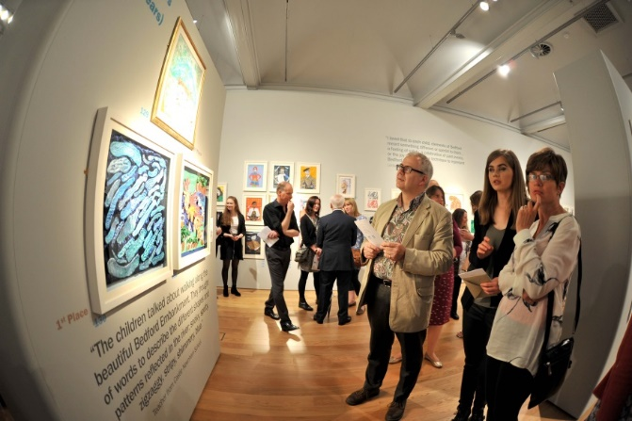 | 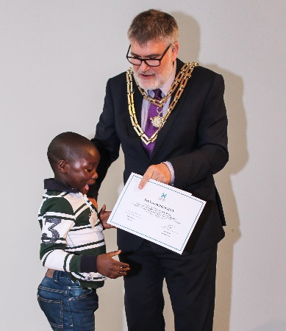 |  | 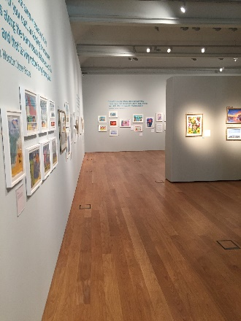
APPLICATION FOR A WORKSHOP WITH A VISITING ARTIST / STAFF INSET WORKSHOP
School based workshops are available for State Schools only
FORM 1
Complete and return ASAP. Workshops allocated on a first come first served.
We are offering 35 free workshops to support the competition. If accepted, the workshop will be delivered in your school, to no more than 30 pupils. We are also offering teacher workshops at the Higgins on 2 separate dates.

Please tick as appropriate
I confirm that my school will be taking part in the Harpur Trust 2020 Art Competition
I would like to apply for a FREE artist workshop at my school
I understand that if I receive a free workshop, and then do not subsequently submit artwork to the competition, my school will be asked to reimburse the Harpur Trust for the cost of the workshop
I would like to book a place on the staff training workshop at the Higgins Bedford (open to all schools subject to availability)
Workshop for Non Specialist Art Teachers on 2nd October 2019
Workshop for Specialist Art Teachers on 9th September 2019

Name of staff member to attend ……………………………………………………………………………..

Either, I would like to target a specific year group(s) for the workshop
Please specify ……………………………………………………………………………..

Or, I would like to target specific children (i.e. intervention groups, pupil premium etc)

We advise smaller groups for the workshop, and no more than 30 children per workshop.

Teacher’s name

School name
School Address
Contact tel number
Contact email Email
Please return before Friday 26th July 2019.
FORM 2
Send in with artwork and with Form 3 on or before 27 Mar 2020.
Complete one form per age category entered.

ART COMPETITION ENTRY FORM

Name and full address of school
Telephone number
Contact teacher name
Contact email address
Category entered
Number of entries submitted in this category (MAXIMUM OF 8)
I confirm that I have read and understood the Terms and Conditions

After the competition I agree to collect the artwork from the Higgins during the period of time specified

Scroll down
ENTRANTS’ DETAILS FORM
FORM 3
- Contact us for an electronic version to type directly onto the form
- Complete one box for each pupil entered (max 8 entries per category)
- CLEARLY and LEGIBLY write the name of the pupil and school name on the back of each piece of work
- Submit one copy of this completed form with your school entry form (Form 2) and hand in with the artwork

1 | PUPIL NAME:  YEAR GROUP: | SCHOOL NAME:  CATEGORY ENTERED:
2 | PUPIL NAME:  YEAR GROUP: | SCHOOL NAME:  CATEGORY ENTERED:
3 | PUPIL NAME:  YEAR GROUP: | SCHOOL NAME:  CATEGORY ENTERED:
4 | PUPIL NAME:  YEAR GROUP: | SCHOOL NAME:  CATEGORY ENTERED:
5 | PUPIL NAME:  YEAR GROUP: | SCHOOL NAME:  CATEGORY ENTERED:
6 | PUPIL NAME:  YEAR GROUP: | SCHOOL NAME:  CATEGORY ENTERED:
7 | PUPIL NAME:  YEAR GROUP: | SCHOOL NAME:  CATEGORY ENTERED:
8 | PUPIL NAME:  YEAR GROUP: | SCHOOL NAME:  CATEGORY ENTERED:

